Develop Soft Phone Agent Plugin

V1.1.0.0 or above

## Softphone Plugin

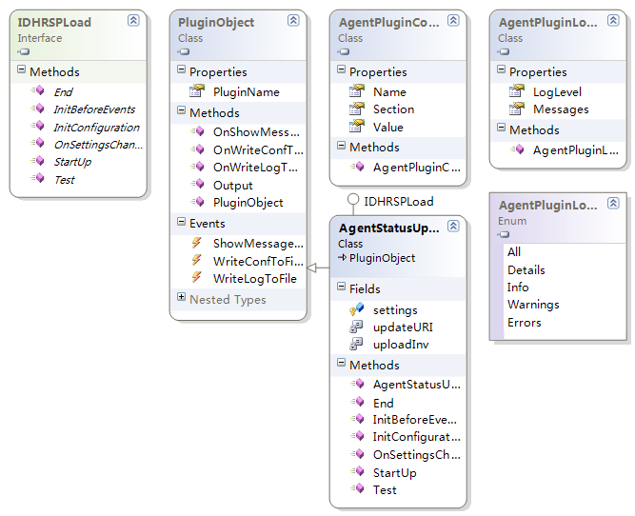

This softphone agent program are made as can load plugin very easy, it can handle most personal information (settings) and computer information to the plugin.

Plugin can easily get this information and be startup with Soft phone agent.

Once you need to get the computer status or tasks on each computer real time, you can make the plugin of the soft phone agent, it is much easy then you make a standalone program as soft phone agent already installed on each DHR member’s computer.

## How to

Plugins can be made under Visual Studio 10 or higher, you may need to implement **IDHRSPLoad** interface and be the sub class of **PluginObject**.

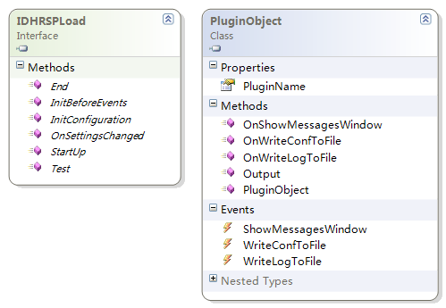

### IDHRSPLoad Interface

Once this interface got implemented, the function of following methods:

End: When the application ending, this method is not working at this moment.

InitBeforeEvents: The plugin must be done all the initial configuration before the soft phone agent connect the events between plugin and main program.

InitConfiguration: Soft phone agent will send all settings for the first time try to get the plugin initialized with Extension Number, Person’s Name, City Name, etc.. And all the settings will should be store in its self.

OnSettingsChanged: This method will be called once the settings was changed in soft phone agent, and args will be send to this method as parameter again.

StartUp: This method will be created as new thread as standalone, and it’s same as main function in plugin, it may need to use keep loop (while(true)) till the soft phone main program ended.

Test: This function must return “OK” as it’s testing function for main program to detect whether it’s plugin of soft phone agent or not.

### PluginObject Class

PluginName: This is a string variable and should be override or set as the plugin’s name in InitBeforeEvents or constructor function.

OnWriteConfToFile: Call this function will write settings to soft phone agent settings file.

OnWriteLogToFile: Call this function will write message to soft phone agent log file.

Output: Not available.

OnShowMessageWindow: Not available.

### Handle Exception

Once there is serious error happens in the plugin, it must be throwing as **AgentException**.

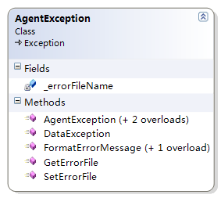

In plugin project, the AgentException must be referenced.

### Log Messages

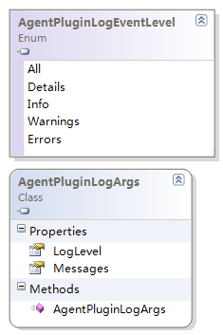

Write message to soft phone agent, it must including the message level, message content. Once the plugin referenced PluginObject, these classes are very easy to use.

For Example:

public void End()

{

OnWriteLogToFile(new AgentPluginLogArgs() { LogLevel = AgentPluginLogEventLevel.Info, Messages = "Ended." });

}

It will write the message “Ended” as Info level to soft phone agent log file.

## Demo

### Demo of Agent Status Uploader

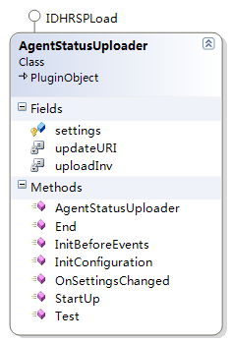

### Code

using System;

using System.Collections.Generic;

using System.Globalization;

using System.IO;

using System.Linq;

using System.Net;

using System.Text;

using System.Threading;

using DHRSoftphone.IDHRSPPlugin;

namespace DHRSoftphone.Plugins.AgentStatusUploader

{

public class AgentStatusUploader : PluginObject, IDHRSPLoad

{

private const string updateURI = "http://softphone.directhr.cn/UploadStatus.asmx/Upload";

private const Int32 uploadInv = 5000;

protected Dictionary<string, string> settings = new Dictionary<string, string>();

public AgentStatusUploader()

{

PluginName = "AgentStatusUploader";

}

public void InitBeforeEvents()

{

OnWriteLogToFile(new AgentPluginLogArgs() { LogLevel = AgentPluginLogEventLevel.Info, Messages = "Inited." });

}

public void StartUp()

{

while (true)

{

…

}

}

public void InitConfiguration(Dictionary<string, string> items)

{

this.settings = items;

OnWriteLogToFile(new AgentPluginLogArgs() { LogLevel = AgentPluginLogEventLevel.Info, Messages = "InitConfigurationed." });

}

public void End()

{

OnWriteLogToFile(new AgentPluginLogArgs() { LogLevel = AgentPluginLogEventLevel.Info, Messages = "Ended." });

}

public void OnSettingsChanged(object sender, Dictionary<string, string> settings)

{

this.settings = settings;

OnWriteLogToFile(new AgentPluginLogArgs() { LogLevel = AgentPluginLogEventLevel.Info, Messages = "OnSettingsChanged." });

}

public string Test()

{

return "OK";

}

}

}

### This Plugin

This plugin using just one class and it does inherit from PluginObject, it’s easy and simple to deal with the person’s information.

Once you need someone’s data on a computer but don’t know his/her extension, fullname, city, areacode, you can just make a plugin of this soft phone agent to deal with.

## Debugging

This soft phone agent also allows you easily see the detail logs, errors, and also easily clean configuration to test it on new computer, etc.

Steps:

1. Open Soft phone agent windows.  
   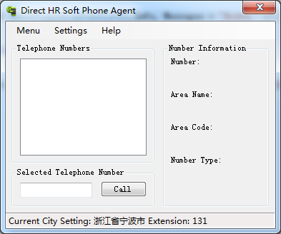
2. Press follow keys on your keyboard,   
   Press “q”  
   Press “z”  
   Press “j”
3. Then this window changed and program into debugging mode. (currently no debugging mode but debugging functions in V1.1.0.0)  
   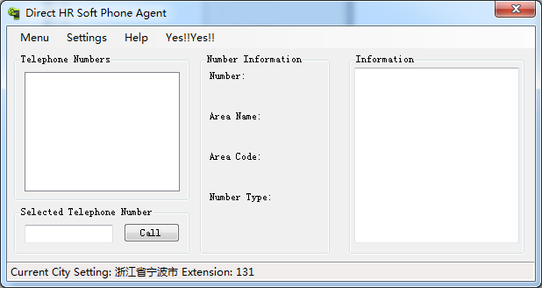
4. In menu “Yes!!Yes!!” is the debugging menu.  
   